Source: Provided by the USDOL https://www.doleta.gov/oa/data_statistics.cfm


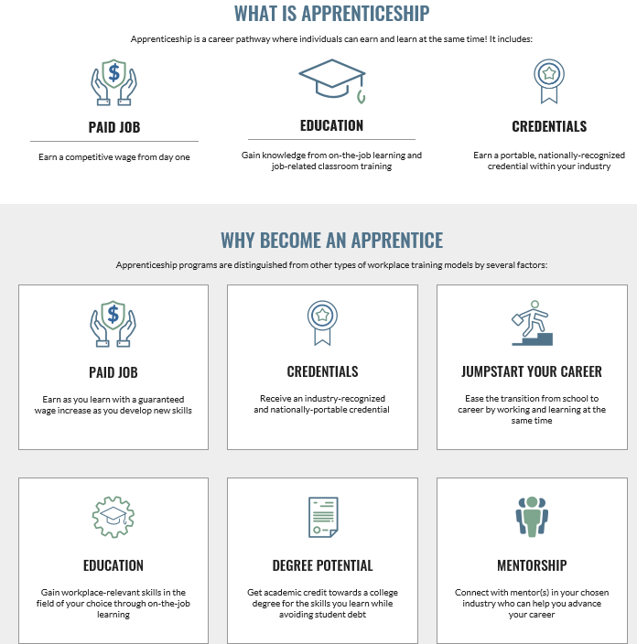

Data and Statistics

Registered Apprenticeship National Results
Fiscal Year (FY) 2018 (10/01/2017 to 9/30/2018)
FY 2018 | FY 2017 | FY 2016 | FY 2015 | FY 2014 | FY 2013 | FY 2012 | FY 2011
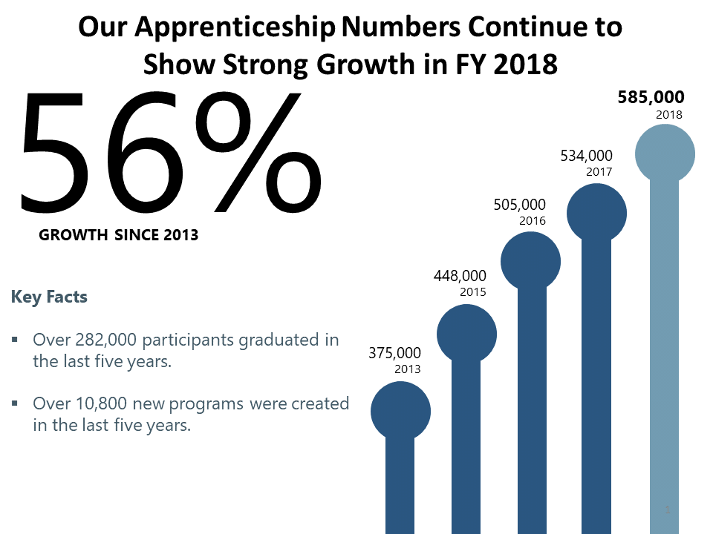
An individual employer, group of employers, labor organization, education institution or an industry association can sponsor an apprenticeship program. Sponsors make significant investments to design and execute apprenticeship programs, provide jobs to apprentices, oversee training development, and provide hands-on learning and technical instruction for apprentices. The programs operate on a voluntary basis and they often receive support by collaborating with community-based organizations, educational institutions, the workforce system, and other stakeholders.
Sponsors can choose to register their program standards and apprentices with the Office of Apprenticeship (OA) or a State Apprenticeship Agency (SAA) recognized by the Department. Registered Apprenticeship Program require a set of structured standards that include requirements for related (classroom) instruction and paid on-the-job learning experiences. Through apprenticeship agreements, sponsors and apprentices agree to the requirements of the program. At the successful completion of the on-the-job and instructional learning, apprentices in a Registered Apprenticeship Program receive an industry-issued, nationally recognized portable certificate of completion.

Apprentices and Participation Trends
- In FY 2018, more than 238,000 individuals nationwide entered the apprenticeship system.
- Nationwide, there are over 585,000 apprentices currently obtaining the skills they need to succeed while earning the wages they need to build financial security.
- 71,700 participants graduated from the apprenticeship system in FY 2018.
- There are over 47,000 veterans nationwide currently participating in an apprenticeship program.

Apprenticeship Sponsors and Trends
- There are more than 23,400 registered apprenticeship programs across the nation.
- 3,229 new apprenticeship programs were established nationwide in FY 2018.

National Apprenticeship Data
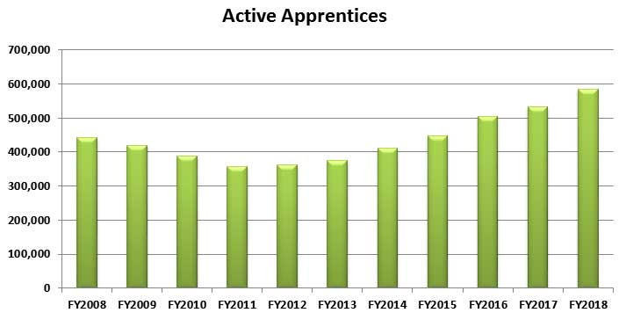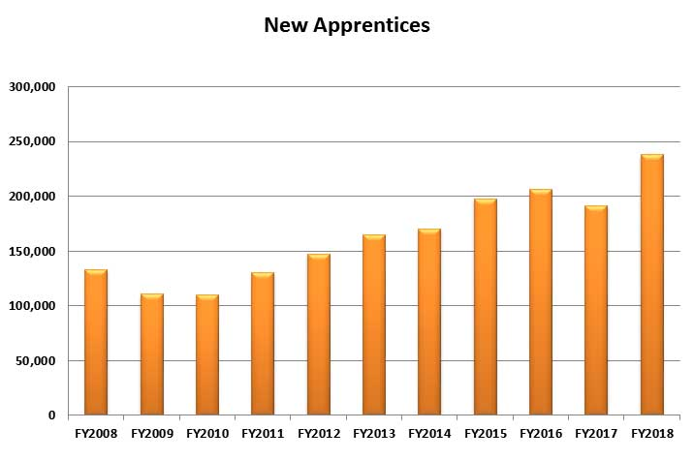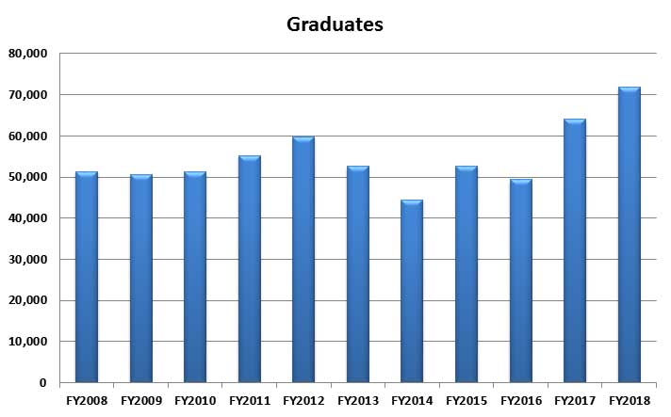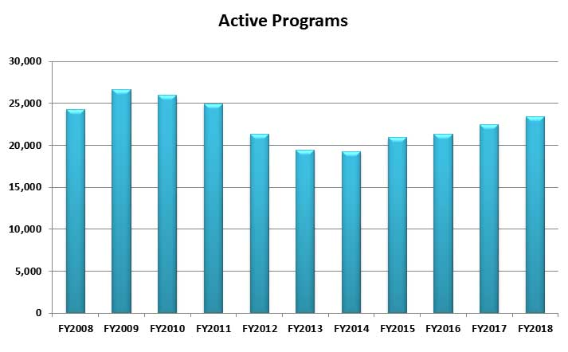
National Registered Apprenticeship Results
Fiscal Year | Active Apprentices | New Apprentices | Total Completers | Active Programs | New Programs
2008 | 442,386 | 132,782 | 51,386 | 24,285 | 1,525
2009 | 420,140 | 110,707 | 50,493 | 26,622 | 1,456
2010 | 387,720 | 109,989 | 51,212 | 25,961 | 1,807
2011 | 357,692 | 130,391 | 55,178 | 24,967 | 1,409
2012 | 362,123 | 147,487 | 59,783 | 21,279 | 1,750
2013 | 375,425 | 164,746 | 52,542 | 19,431 | 1,540
2014 | 410,375 | 170,544 | 44,417 | 19,260 | 1,623
2015 | 447,929 | 197,535 | 52,717 | 20,910 | 1,898
2016 | 505,371 | 206,020 | 49,354 | 21,339 | 1,701
2017 | 533,607 | 191,563 | 64,021 | 22,488 | 2,369
2018 | 585,026 | 238,549 | 71,789 | 23,441 | 3,229

United Service Military Apprenticeship Program Data
The United Services Military Apprenticeship Program (USMAP) is a formal military training program that provides active duty Navy, Coast Guard, and Marine Corps service members the opportunity to improve their job skills and to complete their civilian apprenticeship requirements while they are on active duty. The U.S. Department of Labor (DOL) provides the nationally recognized "Certificate of Completion" upon program completion.
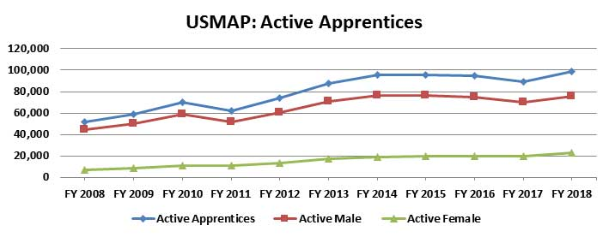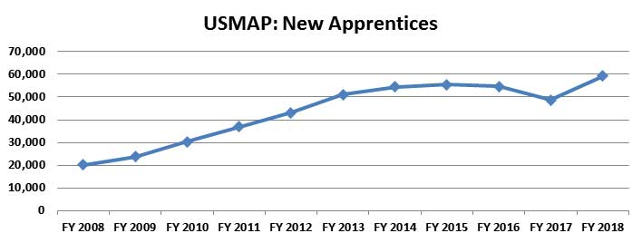
United Services Military Apprenticeship Program (USMAP)
Item | FY 2008 | FY 2009 | FY 2010 | FY 2011 | FY 2012 | FY 2013 | FY 2014 | FY 2015 | FY 2016 | FY 2017 | FY 2018
New Apprentices | 20,200 | 23,650 | 30,323 | 36,831 | 43,155 | 51,001 | 54,430 | 55,445 | 54,756 | 48,715 | 59,379
Active Apprentices | 51,645 | 58,652 | 69,870 | 62,404 | 73,748 | 87,675 | 95,452 | 95,770 | 95,001 | 89,301 | 98,435
Active Male | 44,536 | 50,133 | 58,960 | 51,459 | 60,671 | 70,690 | 76,345 | 76,173 | 75,009 | 69,868 | 75,580
Active Female | 7,109 | 8,519 | 10,910 | 10,945 | 13,077 | 16,985 | 19,107 | 19,597 | 19,992 | 19,433 | 22,855
Total Completers | 2,820 | 3,439 | 4,918 | 5,185 | 6,700 | 8,194 | 9,834 | 11,511 | 11,104 | 12,063 | 12,125

State Apprenticeship Data
Active Apprentices
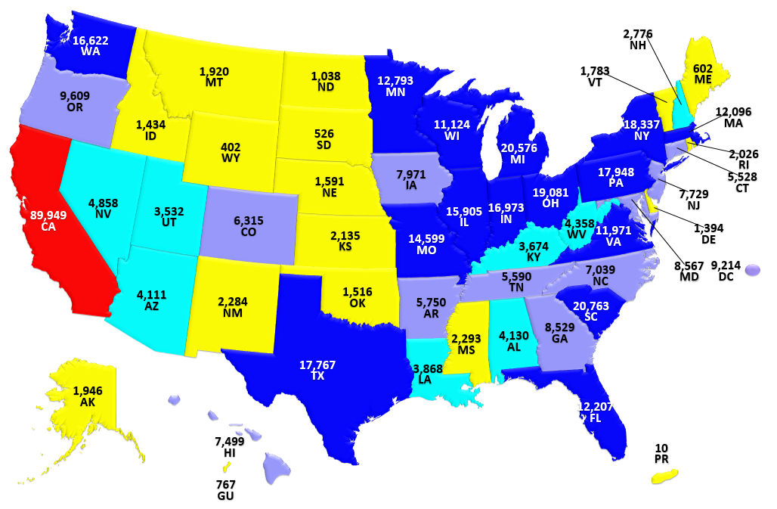
New Apprentices
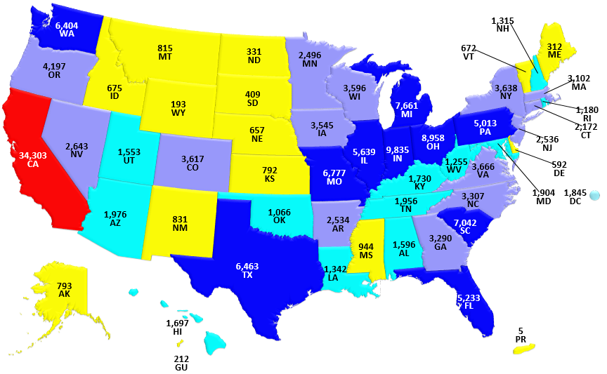
Graduates
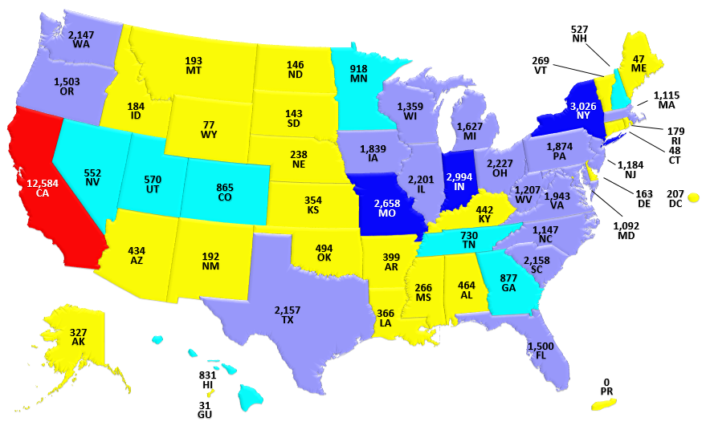
Active Programs
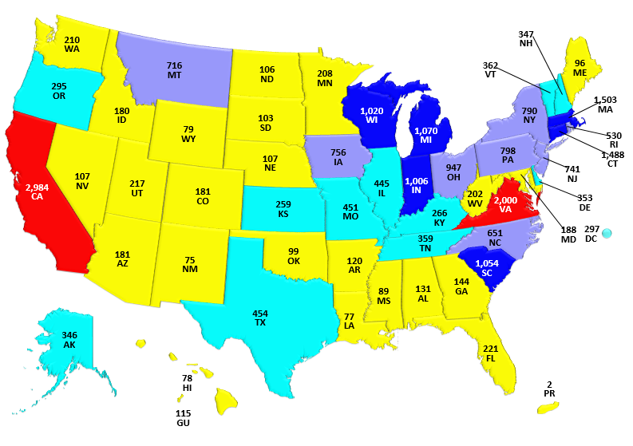
Fiscal Year 2018 State Totals
State Name | Active Apprentices | New Apprentices | Completers | Active Programs | New Programs
State Name | Active Apprentices | New Apprentices | Graduates | Active Programs | New Programs
Alabama | 4,130 | 1,596 | 464 | 131 | 15
Alaska | 1,946 | 793 | 327 | 346 | 49
Arizona | 4,111 | 1,976 | 434 | 181 | 30
Arkansas | 5,750 | 2,534 | 399 | 120 | 11
California | 89,949 | 34,303 | 12,584 | 2,984 | 149
Colorado | 6,315 | 3,617 | 865 | 181 | 23
Connecticut | 5,528 | 2,172 | 48 | 1,488 | 0
Delaware | 1,394 | 592 | 163 | 353 | 60
District of Colombia | 9,214 | 1,845 | 207 | 297 | 208
Florida | 12,207 | 5,233 | 1,500 | 221 | 22
Georgia | 8,529 | 3,290 | 877 | 144 | 16
Guam | 767 | 212 | 31 | 115 | 5
Hawaii | 7,499 | 1,697 | 831 | 78 | 13
Idaho | 1,434 | 675 | 184 | 180 | 47
Illinois | 15,905 | 5,639 | 2,201 | 445 | 38
Indiana | 16,973 | 9,835 | 2,994 | 1,006 | 70
Iowa | 7,971 | 3,545 | 1,839 | 756 | 126
Kansas | 2,135 | 792 | 354 | 259 | 61
Kentucky | 3,674 | 1,730 | 442 | 266 | 65
Louisiana | 3,868 | 1,342 | 366 | 77 | 9
Maine | 602 | 312 | 47 | 96 | 21
Maryland | 8,567 | 1,904 | 1,092 | 188 | 28
Massachusetts | 12,096 | 3,102 | 1,115 | 1,503 | 142
Michigan | 20,576 | 7,661 | 1,627 | 1,070 | 111
Minnesota | 12,793 | 2,496 | 918 | 208 | 4
Mississippi | 2,293 | 944 | 266 | 89 | 7
Missouri | 14,599 | 6,777 | 2,658 | 451 | 64
Montana | 1,920 | 815 | 193 | 716 | 115
Nebraska | 1,591 | 657 | 238 | 107 | 11
Nevada | 4,858 | 2,643 | 552 | 107 | 27
New Hampshire | 2,776 | 1,315 | 527 | 347 | 39
New Jersey | 7,729 | 2,536 | 1,184 | 741 | 131
New Mexico | 2,284 | 831 | 192 | 75 | 11
New York | 18,337 | 3,638 | 3,026 | 790 | 99
North Carolina | 7,039 | 3,307 | 1,147 | 651 | 103
North Dakota | 1,038 | 331 | 146 | 106 | 20
Ohio | 19,081 | 8,958 | 2,227 | 947 | 43
Oklahoma | 1,516 | 1,066 | 494 | 99 | 7
Oregon | 9,609 | 4,197 | 1,503 | 295 | 19
Pennsylvania | 17,948 | 5,013 | 1,874 | 798 | 42
Puerto Rico | 10 | 5 | 0 | 2 | 0
Rhode Island | 2,026 | 1,180 | 179 | 530 | 83
South Carolina | 20,763 | 7,042 | 2,158 | 1,054 | 148
South Dakota | 526 | 409 | 143 | 103 | 3
Tennessee | 5,590 | 1,956 | 730 | 359 | 14
Texas | 17,767 | 6,463 | 2,157 | 454 | 43
Utah | 3,532 | 1,553 | 570 | 217 | 15
Vermont | 1,783 | 672 | 269 | 362 | 432
Virginia | 11,971 | 3,666 | 1,943 | 2,000 | 354
Washington | 16,622 | 6,404 | 2,147 | 210 | 8
West Virginia | 4,358 | 1,255 | 1,207 | 202 | 7
Wisconsin | 11,124 | 3,596 | 1,359 | 1,020 | 150
Wyoming | 402 | 193 | 77 | 79 | 7

DATA NOTE: US DOL's Office of Apprenticeship uses a combination of individual records and aggregate state reports to calculate national totals as depicted on this webpage. The Registered Apprenticeship Partners Information Management Data System (RAPIDS) captures individual record data from 25 Office of Apprenticeship (OA) states and 14 of the 28 State Apprenticeship Agency (SAA) states/territories. For SAA states that manage their data outside of RAPIDS, information is provided in the aggregate to US DOL on a quarterly basis.

Federal Apprenticeship Data
The Federal data below is a summary of the data managed by Department of Labor staff in the 25 OA states and federally administered programs in SAA states.
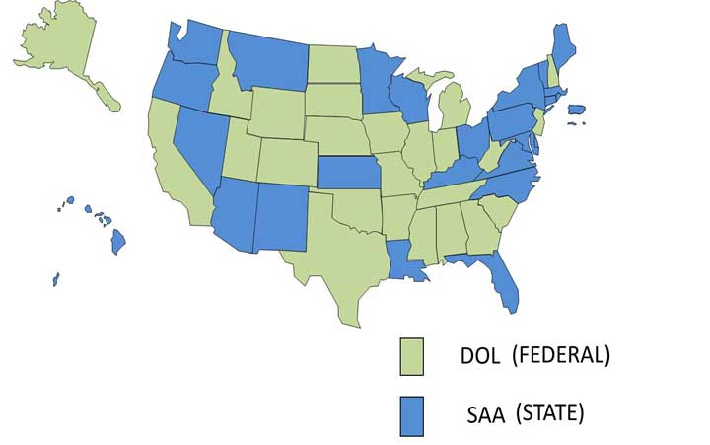
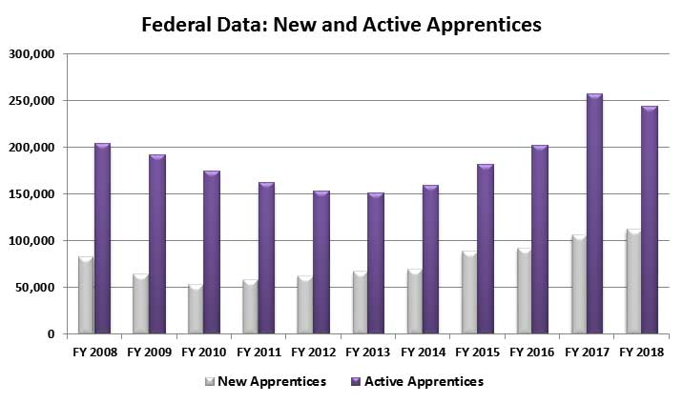
Federal Data
Item | FY 2008 | FY 2009 | FY 2010 | FY 2011 | FY 2012 | FY 2013 | FY 2014 | FY 2015 | FY 2016 | FY 2017 | FY 2018
New Apprentices | 83,017 | 64,690 | 53,233 | 57,809 | 62,167 | 67,195 | 69,487 | 89,210 | 91,777 | 106,117 | 112,365
Active Apprentices | 204,160 | 191,806 | 174,536 | 161,935 | 152,543 | 150,170 | 159,776 | 182,176 | 202,817 | 257,919 | 244,609
New Programs | 1,145 | 1,072 | 940 | 801 | 898 | 590 | 612 | 686 | 636 | 983 | 1,075
Active Programs | 12,146 | 11,915 | 11,404 | 10,223 | 10,166 | 9,539 | 8,828 | 8,606 | 8,610 | 9,117 | 9,227
Program Completers | 37,466 | 29,054 | 29,393 | 29,957 | 29,284 | 26,141 | 22,380 | 23,578 | 24,965 | 27,749 | 33,741
Federal Data: Top 30 Occupationâ€”Federal Workload (Fiscal Year 2018)
Occupation Title | O*NET Code | Active Apprentices
Electrician | 47-2111.00 | 43,814
Carpenter | 47-2031.00 | 25,921
Construction Craft Laborer | 47-2061.00 | 15,612
Plumber | 47-2152.02 | 14,471
Truck Driver, Heavy | 53-3032.00 | 11,410
Pipe Fitter | 47-2152.01 | 8,449
Line Maintainer | 49-9051.00 | 7,374
Sheet Metal Worker | 47-2211.00 | 7,364
Dry-Wall Applicator | 47-2081.00 | 5,991
Structural Steel Worker | 47-2221.00 | 5,852
Roofer | 47-2181.00 | 4,411
Millwright | 49-9044.00 | 4,244
Sprinkler Fitter | 47-2152.01 | 4,110
Operating Engineer | 47-2073.00 | 3,923
Elevator Constructor | 47-4021.00 | 3,711
Painter | 47-2141.00 | 3,337
Protective Service Specialist (Active Duty Military) | 33-3051.01 | 2,952
Heating & Air-Conditioner Install/Servicer | 49-9021.01 | 2,564
Reinforcing Metal Worker | 47-2171.00 | 2,503
Pharmacy Support Staff | 29-2052.00 | 2,192
Telecommunications Technician | 49-2022.00 | 2,172
Cement Mason | 47-2051.00 | 2,151
Boilermaker | 47-2011.00 | 2,051
Nurse Assistant | 31-1014.00 | 1,914
Cook | 35-2012.00 | 1,908
Line Installer-Repairer | 49-9052.00 | 1,907
Fitter | 51-2041.00 | 1,713
Fire Fighter | 33-2011.00 | 1,692
Glazier | 47-2121.00 | 1,682
Floor Layer | 47-2042.00 | 1,652
Federal Data: Active Apprentices by Industry for Fiscal Year 2018
Industry Title | Active Apprentices
Construction | 166,629
Military (USMAP) | 98,435
Public Administration | 19,447
Manufacturing | 15,630
Transportation and Warehousing | 12,335
Utilities | 7,281
Health Care and Social Assistance | 4,507
Educational Services | 3,690
Retail Trade | 3,545
(not listed) | 3,262
Wholesale Trade | 2,193
Other Services (except Public Administration) | 1,195
Information | 1,152
Administrative and Support and Waste Management and Remediation Services | 1,067
Accommodation and Food Services | 761
Agriculture, Forestry, Fishing and Hunting | 761
Professional, Scientific, and Technical Services | 493
Mining, Quarrying, and Oil and Gas Extraction | 425
Finance and Insurance | 145
Arts, Entertainment, and Recreation | 47
Real Estate and Rental and Leasing | 44

Data Definitions
New Apprentices: apprentices registered during the period (The begin date, not the registration date is used).
New Programs: programs registered during the period.
Active Apprentices: includes registered (RE), suspended (SU), and reinstated (RI) apprentices.
Active Programs: includes registered (RE), suspended (SU), and reinstated (RI) programs.
Active Apprentices/Programs: active count at the end of a period (active at beginning of period + new during period - completed/cancelled during period).
Graduates: apprentices that have completed during the period.

