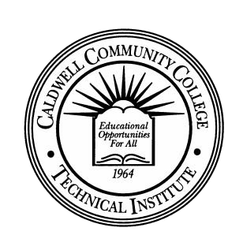

**Community College**

**Student Consent for Release of**

**Non-Directory Information**

FERPA (Family Educational Rights and Privacy Act) is a federal statute that precludes X Community College from providing student record information to anyone but the student without the student’s written authorization

By completing this form, you are authorizing X Community College to release information regarding your student record(s) to the individuals listed below. This includes (but is not limited to) information related to financial aid, billing, attendance, grades, advising, etc. I understand the individuals below must provide my student ID# and birthdate in order to conduct any College business on my behalf, and it is my responsibility to provide this information to them. This release replaces all previous authorizations and is in effect from the date signed until I submit a request revising or revoking the release of information.

Proof of an unexpired government ID will be required from you when submitting this form. Proof of an unexpired government ID will also be required from the individual(s) to whom access has been granted when requesting information about you.

I grant permission to X Community College and

*Student’s Name (Please Print)*

to release non-directory information to: (list individuals below) Name of Individual: Relationship:

This permission remains in effect until I cancel by notifying the Student Services Office in writing.

*Check only if you currently have a Consent for Release of Non-Directory Information on file.*



I, the undersigned, do rescind prior authorization given to the third parties for release of information.

Signature of Student Student ID Number Date

Signature of Student Services Office Witness Date

Revised 4/25/18