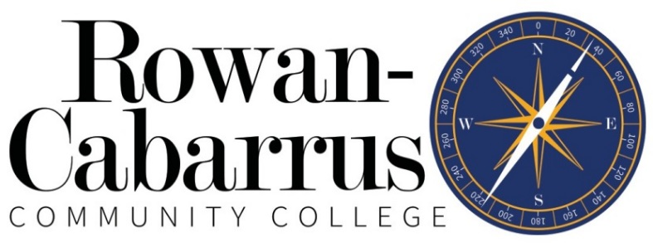
The Office of Accessibility
Sign Language Interpreter/Transliterator Services Request
The Office of Accessibility provides interpreters/transliterators for Rowan-Cabarrus Community College related functions. If your request can’t be filled you will be contacted; otherwise, expect an interpreter to meet you at your appointment. The Office of Accessibility requires three business days to make these arrangements. Please advise The Office of Accessibility immediately if you cancel or change your plans: Holly.Wagoner@rccc.edu /704.216.3639 or Joanne.Rusnak@rccc.edu /704.216.3613.
Please submit this form to one of The Office of Accessibility providers listed above at least three business days before your event.

Today’s date: _________________________
I need a (check one): ASL Interpreter ____
CART transliterator ____
Day and date: _________________________________________ Time: _____________________
Campus: ____________ Building: ______________ Room number: ____________________
For: _________________________________________________________________________________
(Course name/number/section, scheduled school event, appointment with faculty/staff, etc)
Expected length of appointment/meeting: __________________________________________________
Your name: ___________________________________________________________________________
Your phone number: _____________________ Your email: ____________________________________

FOR OFFICE USE ONLY
Interpreter assigned/agency: _____________________________________________________________
The Office of Accessibility Provider Signature: ____________________________ Date: ______________

