NCCCS

Student Leadership Development Program

Fall Mini-Session

Greensboro-High Point Marriott Airport

Greensboro, NC

Friday, Nov. 3 – Saturday, Nov. 4, 2017

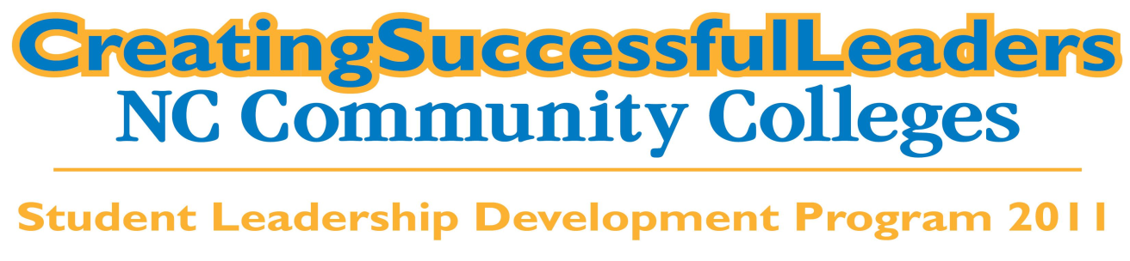



**2017 – 2018 Student Leadership Development Program Staff**

***Director***

John J. Evans

***Group Facilitators***

Shane Bryson – Red Group

Brooke Dove - Green Group  
Renita Johnson - Purple Group

Gilbert Umberger - Gold Group

***Assistant Facilitators***

Kirsten Stovall - Green Group

Jessica Quint - Gold Group

Julio David Zuarth - Red Group

Marshall Mulzoff - Purple Group

***Communications Coordinator***

Donna Reaves

***Special Thanks to:***

The SLDP Staff

NC Association of Community College Presidents

Guilford Technical Community College  
Center for Creative Leadership, LLC.

The SLDP Advisory Board  
Mrs. Berri Cross  
NCCCS Staff

**2016-2017 SLDP Fall Mini-Session**

**Friday, November 3 – Sunday, November 4, 2017**

# Greensboro, NC

**Friday, October 21, 2016**

Please Drive Safely

12:00 p.m. - 1:30 p.m. Lunch / Campus Reports & Updates

GTCC Aviation Campus III

[1053 Old Stage Coach Road, Greensboro, NC 27410]

2:00 p.m. - 3:00 p.m. “Workshop One”

3:00 p.m. – 4:00 p.m. “Workshop Two”

4:00 p.m. – 4:30 p.m. Break

4:30 p.m. – 5:30 p.m. “Workshop Three”

5:30 p.m. – 6:00 p.m. Project

6:00 p.m. – 8:00 p.m. Dinner on Your Own / Networking / Project

8:00 p.m. – 9:30 p.m. Social Event: Bowling

9:30 p.m. - Until Networking / Project

**Saturday, October 22, 2016**

8:00 a.m. - 9:00 a.m. Breakfast

9:00 a.m. – 10:00 a.m. Hotel Check Out / Transition to the Center for Creative Leadership

[1 Leadership Place, Greensboro, NC 27410] <https://www.ccl.org/>

10:00 a.m. - 12:00 p.m. Center for Creative Leadership Workshop / Training

12:00 p.m. - 12:30 p.m. Announcements and Wrap-Up

12:30 p.m. Travel Safely

**Hotel Accommodations**

# Greensboro-High Point Marriott Airport

1 Marriott Drive, Greensboro, NC 27409

336-852-6450

**2017 – 2018 Student Leadership Development Program**

**Student Participants**

|  |  |
| --- | --- |
| **Bare, Landon** | Randolph CC |
| **Bellflowers, Rachel** | Gaston College |
| **Boggess, Zion** | Wilkes CC |
| **Bryant, Maya** | Nash CC |
| **Dunn, Ayla** | Piedmont CC |
| **Estes, Sarah** | Caldwell CC&TI |
| **Floyd, Stacey** | James Sprunt CC |
| **Gilchrist, Tynsley** | Caldwell CC&TI |
| **Goins, Brianna** | Guildford Tech CC |
| **Gooden, Roderick** | Fayetteville Tech CC |
| **Horton, Natalie** | Rockingham CC |
| **Jones, Dustin** | Catawba Valley CC |
| **Kirstein, David** | Wake Tech CC |
| **Lewis, Larrell** | Halifax CC |
| **Lyon, Noelle** | Durham Tech CC |
| **Marquette, Taylor** | Forsyth Tech |
| **Martinez, Noel** | Central Carolina CC |
| **McKinney, Angela** | Isothermal CC |
| **Nobles, Matthew** | Southeastern CC |
| **Reeves, Justin** | Catawba Valley CC |
| **Rivera, Ezequiel** | South Piedmont CC |
| **Simmons, Camille** | Forsyth Tech CC |
| **Simpkins, Blake** | Pitt CC |
| **Smith-Barrett, Gabrielle** | Wake Tech CC |
| **Taylor, Charity** | Bladen CC |
| **Thompson, Marie** | Johnston CC |
| **Toohey, Tyler** | Craven CC |
| **Vigneaux Carrie** | Carteret CC |
| **Walker, Liana** | Rowan-Cabarrus CC |
| **Watt, Brandon** | Randolph CC |
|  |  |

*“If your actions inspire others to dream more, learn more,*

*do more and become more, you are a leader*.” **John Quincy Adams**

**Mini Session Bios**

**Presenters**

2017 - 2018