Curricular Priorities and Assessments
Excerpted from Understanding by Design (2005) by Grant Wiggins and Jay McTighe

Assessment Types
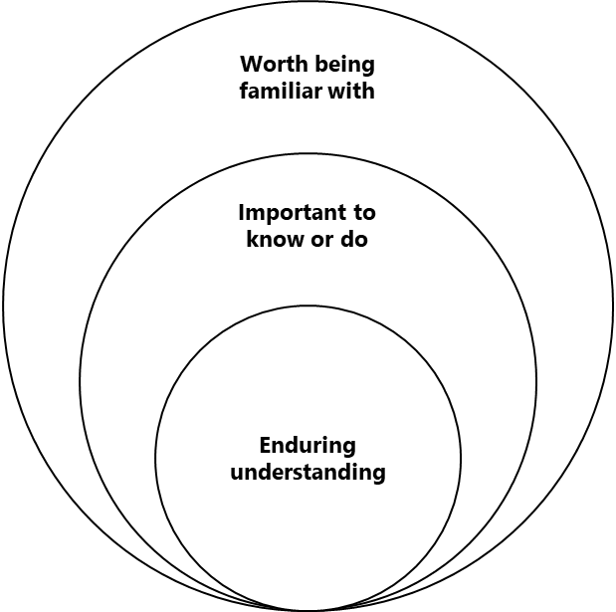

Traditional quizzes and tests
- Paper/pencil
  - selected-response
  - constructed-response

Performance tasks and projects
- open-ended
- complex
- authentic

Quiz and Test Items
These are simple, content-focused questions. They
- Assess for factual information, concepts, and discrete.
- Use selected-response or short-answer formats.
- Are convergent—typically they have a single, best answer.
- May be easily scored using an answer key (or machine scoring).
- Are typically secure (not known in advance).

Academic Prompts
These are open-ended questions or problems that require the student to think critically, not just recall knowledge, and then to prepare a response, product, or performance. They
- Require constructed responses under school or exam conditions.
- Are open with no single, best answer or best strategy for answering or solving them.
- Often are ill-structured, requiring the development of a strategy.
- Involve analysis, synthesis, or evaluation.
- Typically require an explanation or defense of the answer given or methods used.
- Require judgment-based scoring based on criteria and performance standards.
- May or may not be secure.

Performance Tasks and Projects
As complex challenges that mirror the issues and problems faced by adults, they are authentic. Ranging in length from short-term tasks to long-term, multi-staged projects, they require a production or performance. They differ from prompts because they
- Feature a setting that is real or simulated: one that involves the kind of constraints, background noise, incentives, and opportunities an adult would find in a similar situation.
- Typically require the student to address an identified audience.
- Are based on a specific purpose that relates to the audience.
- Allow the student greater opportunity to personalize the task.
- Are not secure. Task, criteria, and standards are known in advance and guide the student’s work.

The Six Facets of Understanding

Facet 1. A student who really understands can explain. She demonstrates sophisticated explanatory power and insight. She can
- Provide complex, insightful, and credible reasons—theories and principles, based on good evidence and argument—to explain or illuminate an event, fact, text, or idea; provide a systematic account, using helpful and vivid mental models.
  - Make fine, subtle distinctions; aptly qualify her opinions.
  - See and argue for what is central—the big ideas, pivotal moments, decisive evidence, key questions, and so on.
  - Make good predictions.
- Avoid or overcome common misunderstandings and superficial or simplistic views—shown, for example, by avoiding overly simplistic, hackneyed, or imprecise theories or explanations.
- Reveal a personalized, thoughtful, and coherent grasp of a subject—indicated, for example, by developing a reflective and systematic integration of what she knows effectively and cognitively. This integration would therefore be based in part upon significant and apt direct or simulated experience of specific ideas or feelings. Substantiate or justify her views with sound argument and evidence.

Facet 2. A student who really understands can interpret. He offers powerful, meaningful interpretations, translations, and narratives. He can
- Effectively and sensitively interpret texts, language, and situations—shown, for example, by the ability to “read between the lines” and offer plausible accounts of the many possible purposes and meanings of any “text” (e.g., book, situation, or human behavior).
- Offer a meaningful and illuminating account of complex situations and people. He has the ability, for example, to provide historical and biographical background, thereby helping to make ideas more accessible and relevant.
Facet 3. A student who really understands can apply. She uses knowledge in context, has know-how. She can
- Employ her knowledge effectively in diverse, authentic, and realistically messy contexts.
- Extend or apply what she knows in a novel and effective way—that is, invent in the sense of innovate, as Piaget (1973) discusses in To Understand Is to Invent.
- Effectively self-adjust as she performs.

Facet 4. A student who really understands sees in perspective. He can
- Critique and justify a position to see it as a point of view; to use skills and dispositions that embody disciplined skepticism and the testing of theories.
- Know the history of an idea to place discussion and theory in context; know the questions or problem to which the knowledge or theory studied is an answer or solution.
- Infer the assumptions upon which an idea or theory is based.
- Know the limits as well as the power of an idea.
- See through argument or language that is biased, partisan, or ideological.
- See and explain the importance or worth of an idea.
- Wisely employ both criticism and belief, an ability summarized by Peter Elbow’s (1973) maxim that we are likely to better understand when we methodically “believe when others doubt and doubt when others believe.”

Facet 5. A student who really understands demonstrates empathy. She has the ability to sensitively perceive. She can
- Project herself into, feel, and appreciate another’s situation, affect, or point of view.
- Operate on the assumption that even an apparently odd or obscure comment, text, person, or set of ideas may contain insights that justify working to understand it.
- See when incomplete or flawed views are plausible, even insightful, though perhaps somewhat incorrect or outdated.
- See and explain how an idea or theory can be all too easily misunderstood by others.
- Listen—and hear what others often do not.

Facet 6. A student who really understands reveals self-knowledge. He can
- Recognize his own prejudices and style, and how they color understanding; see and get beyond egocentrism, ethnocentrism, present-centeredness, nostalgia, and either-or thinking.
- Engage in effective metacognition; recognize intellectual style, strengths, and weaknesses.
- Question his own convictions; like Socrates, able to sort out mere strong belief and habit from warranted knowledge, be intellectually honest, and admit ignorance.
- Accurately self-assess and effectively self-regulate.
- Accept feedback and criticism without defensiveness.

