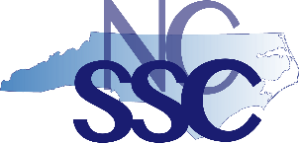**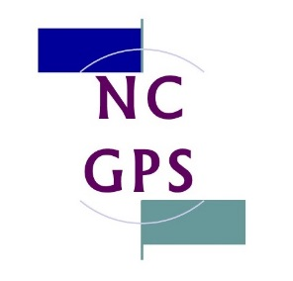NC Guided Pathways to Success Network**

**2018 Cohort**

**NIC Facilitators Institute**

**Tuesday, May 15 & Wednesday, May 16, 2018**

[**Catholic Conference Center, Hickory**](https://catholicconference.org/about/)

**GOALS**

By the end of the institute, participants will understand and apply knowledge in context about

1. NC GPS project goals, timeline, activities, and outcomes
2. The NC Community College System, cohort colleges, and our students
3. Institutional and system-level change roles, processes, and timelines
4. Guided Pathways (NC GPS) principles and practices
5. NICs and improvement science roles, processes, and outcomes

**AGENDA Tuesday, May 15**

*8:00 Optional for early arrivals*

* *Breakfast buffet*
* *Networking conversations*
* *Individual study time*

10:00 Opening session

12:00 Lunch & guided discussions

12:30Student success: national & NC Community College System perspectives

1:30 Guided Pathways to Success (GPS) principles & practices

2:15 Break

2:30 Organizational learning & change leadership

3:45 Break

4:00 Improvement tools & identifying problems in practice #1

5:15 Assessment & individual reflections

5:30 Break

6:00 Dinner with your team: guided discussions & networking

6:45 Improvement tools & identifying problems in practice #2

*8:00 Optional social:* [*Olde Hickory Tap Room*](http://www.oldehickorytaproom.com/index.html) *[carpool to downtown Hickory location]*

**AGENDA Wednesday, May 16**

8:00 Breakfast buffet

* Team conversations
* Check out of Conference Center
* Submit forms in folders to Roxanne

9:00 Day 1 reflections

9:30 GPS Scale of Adoption Assessment (SOAA)

10:45 Break

11:00 SOAA validating & coaching

12:00 Lunch & team conversations

12:30 NIC Facilitators leading change: preparing for the Cohort Institute I on May 29-30

1:30 Assessment & individual reflections

2:00 Institute concludes—wishing you safe travels home!

*Revised 5.13.18*