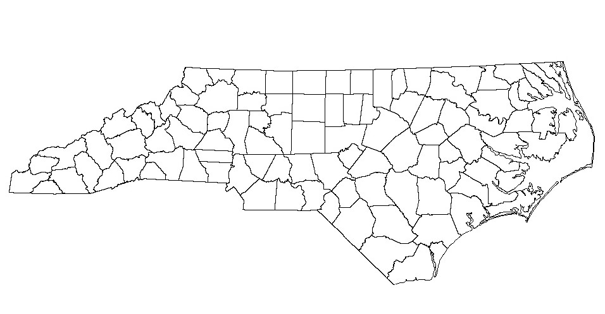**North Carolina**

*Esse quam videri*

To be, rather than to seem.