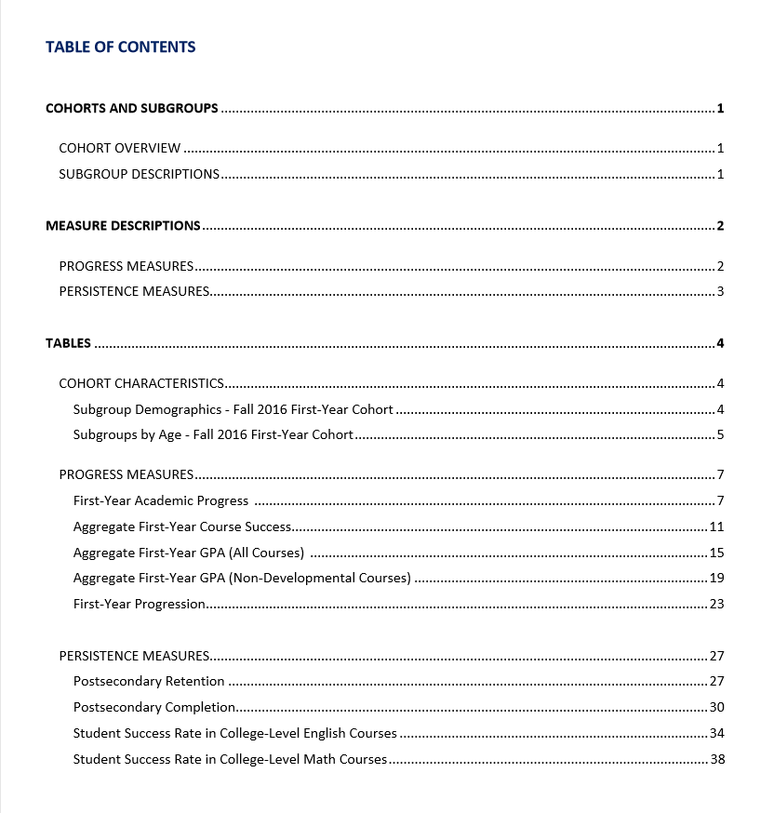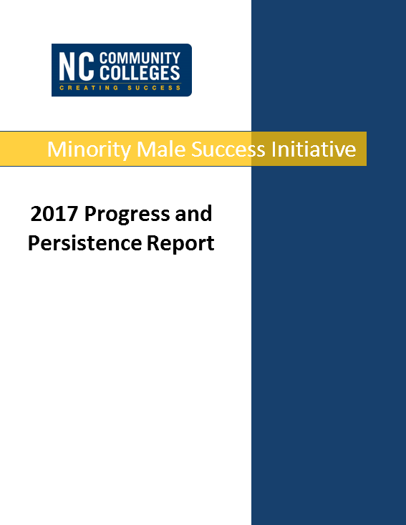 <http://www.nccommunitycolleges.edu/sites/default/files/basic-pages/student-services/mmm_2017_report_data_20170924.pdf>

**PROGRESS MEASURES**

**Academic Progress Standard -** Percentage of first-time minority male students meeting the minimum satisfactory academic progress standards of a cumulative GPA of 2.0 and 67% rate during their first fall and spring semesters.

**First Year Progression -** Percentage of first‐time minority male students attempting at least 12 hours within their first academic year who successfully complete at least 12 of those hours.

**Aggregate First-Year GPA -** Cumulative first-year GPA of first‐time minority male students

**First Year Successful Credit Hour Completion -** Percentage of credit hours successfully completed (C or better) during first academic year

**PERSISTENCE MEASURES**

**Postsecondary Retention -** Percentage of first-time minority male students enrolling in or graduating by second fall semester.

**Student Success Rate in College‐Level English Courses -** Percentage of first‐time minority male Associate Degree seeking and transfer pathway students passing a credit‐bearing English course with a “C” or better within their first two academic years.

**Student Success Rate in College‐Level Math Courses -** Percentage of first‐time minority male Associate Degree seeking and transfer pathway students passing a credit‐bearing Math course with a “C” or better within their first two academic years.

**Postsecondary Completion -** Percentage of all minority male students graduating or transferring by subsequent fall semester.

**Academic Progress Standard** - Fall 2015 Cohort

Percentage of students meeting the minimum satisfactory academic progress standards (a cumulative GPA of 2.0 and 67% rate) during the fall and spring semester of their first academic year.

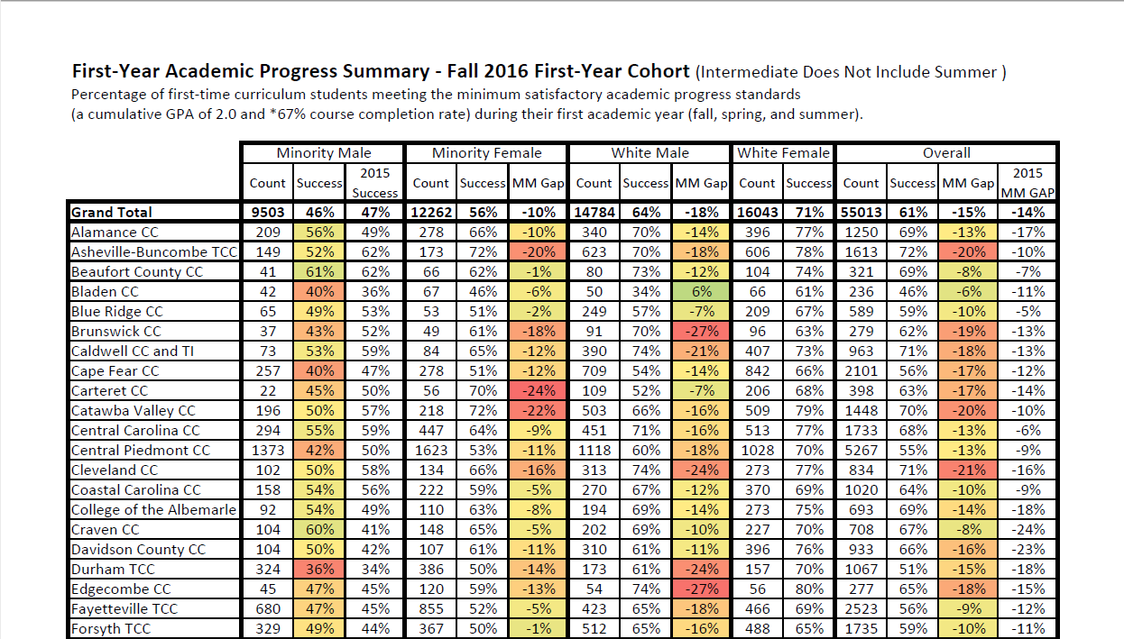

|  |  |
| --- | --- |
| **Success Rates** | **Success Gaps** |

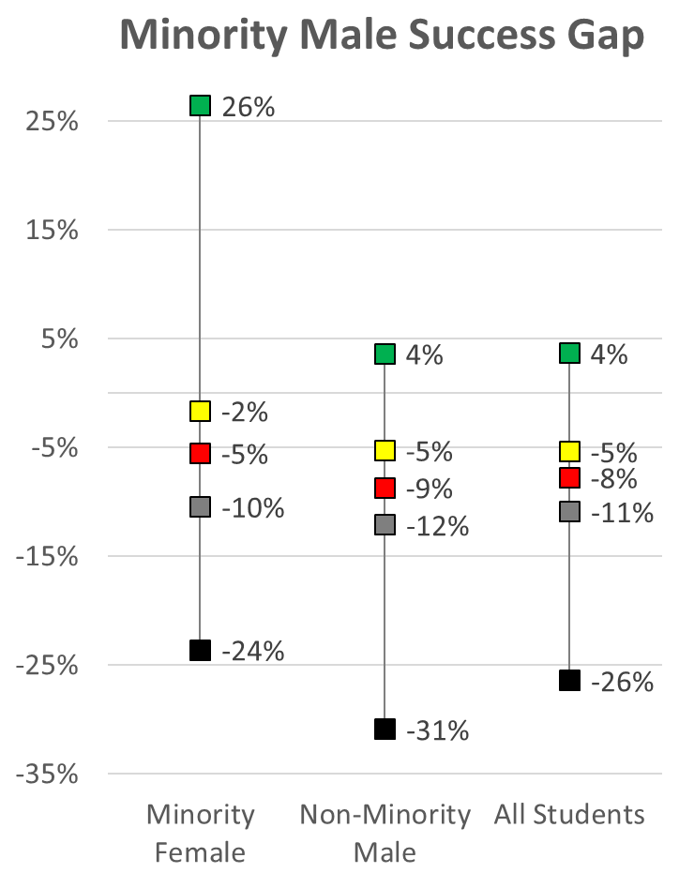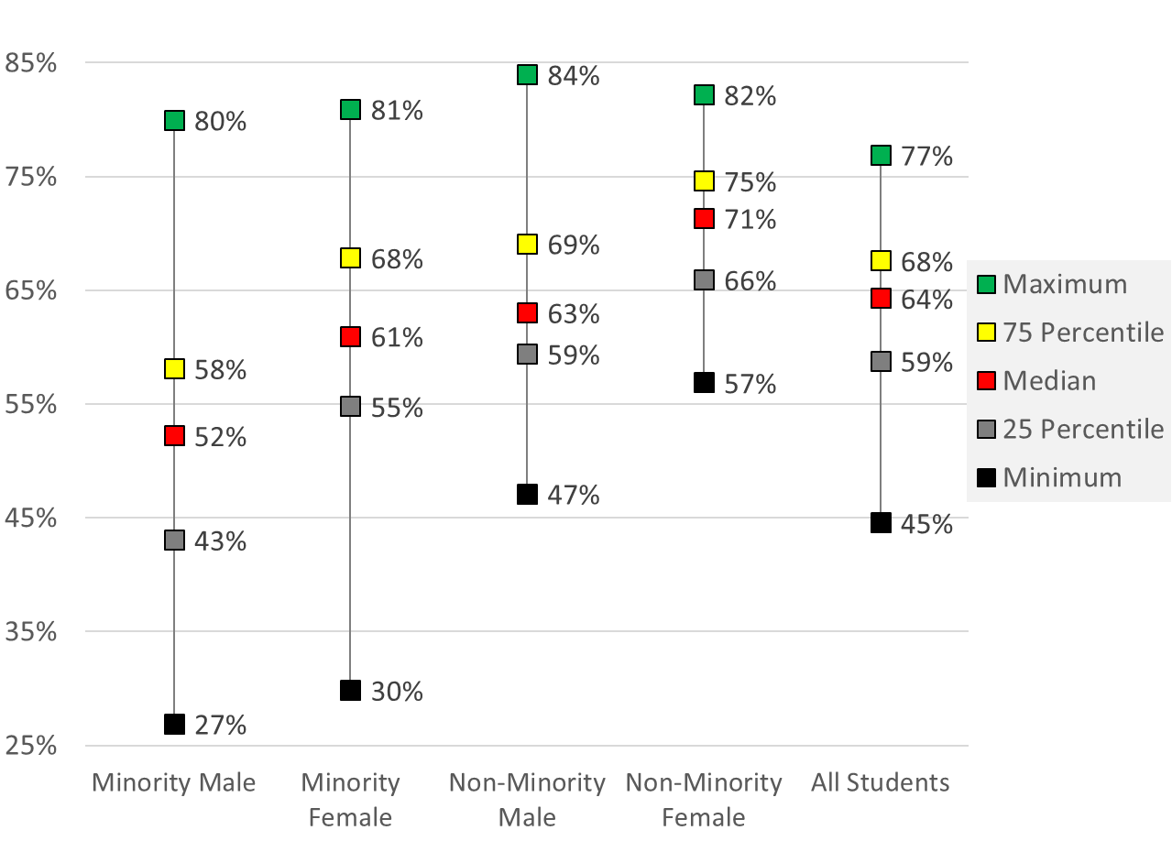

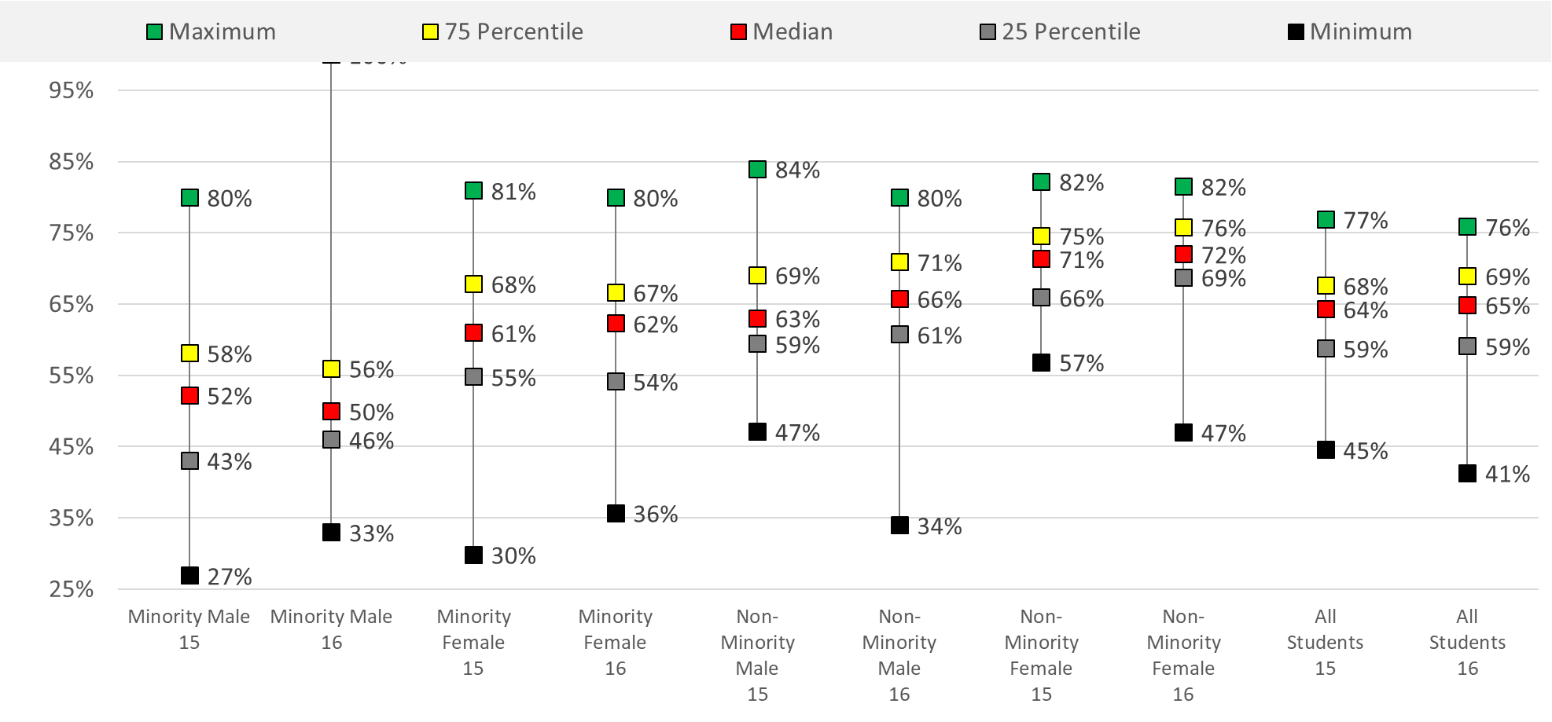

**Academic Progress Standard** - Fall 2015 Cohort

Percentage of students meeting the minimum satisfactory academic progress standards (a cumulative GPA of 2.0 and 67% rate) during the fall and spring semester of their first academic year.

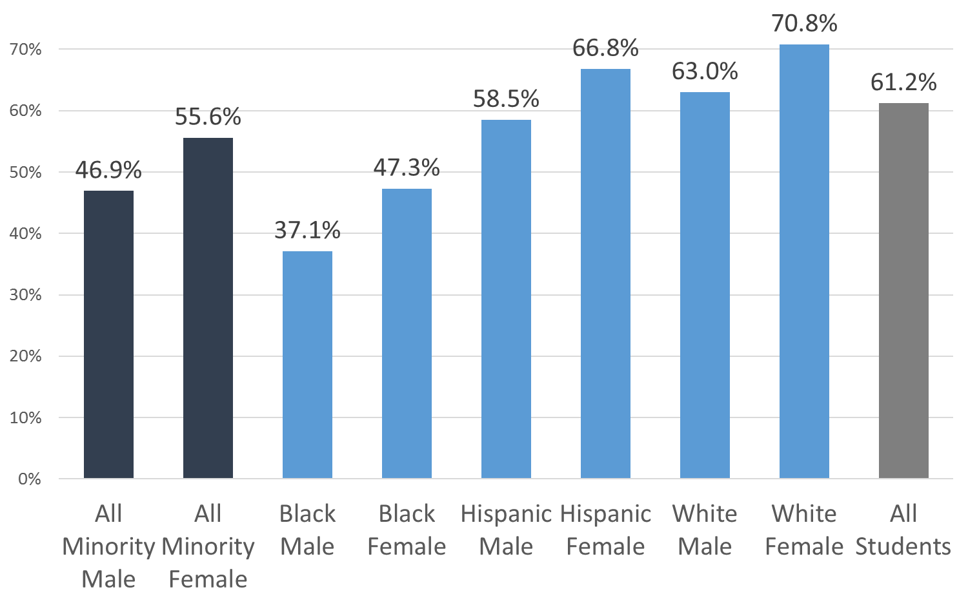

**Aggregate First-Year GPA** - Fall 2015 Cohort

Cumulative first-year GPA of first‐time students

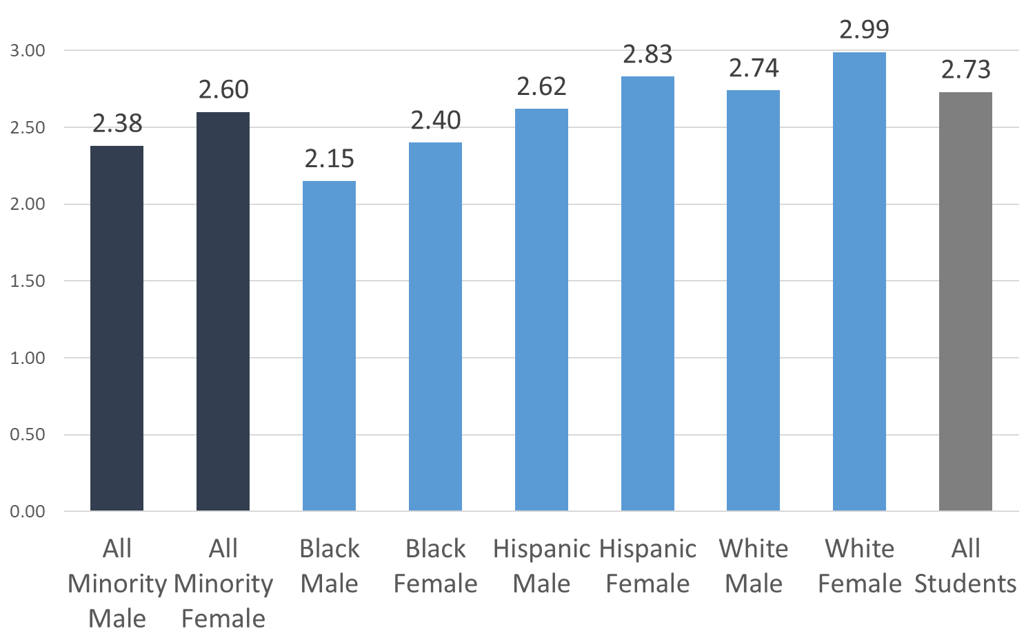

**First-Year Successful Credit Hour Completion** - Fall 2015 Cohort

Percentage of credit hours successfully completed (C or better) during first academic year for entire subgroup

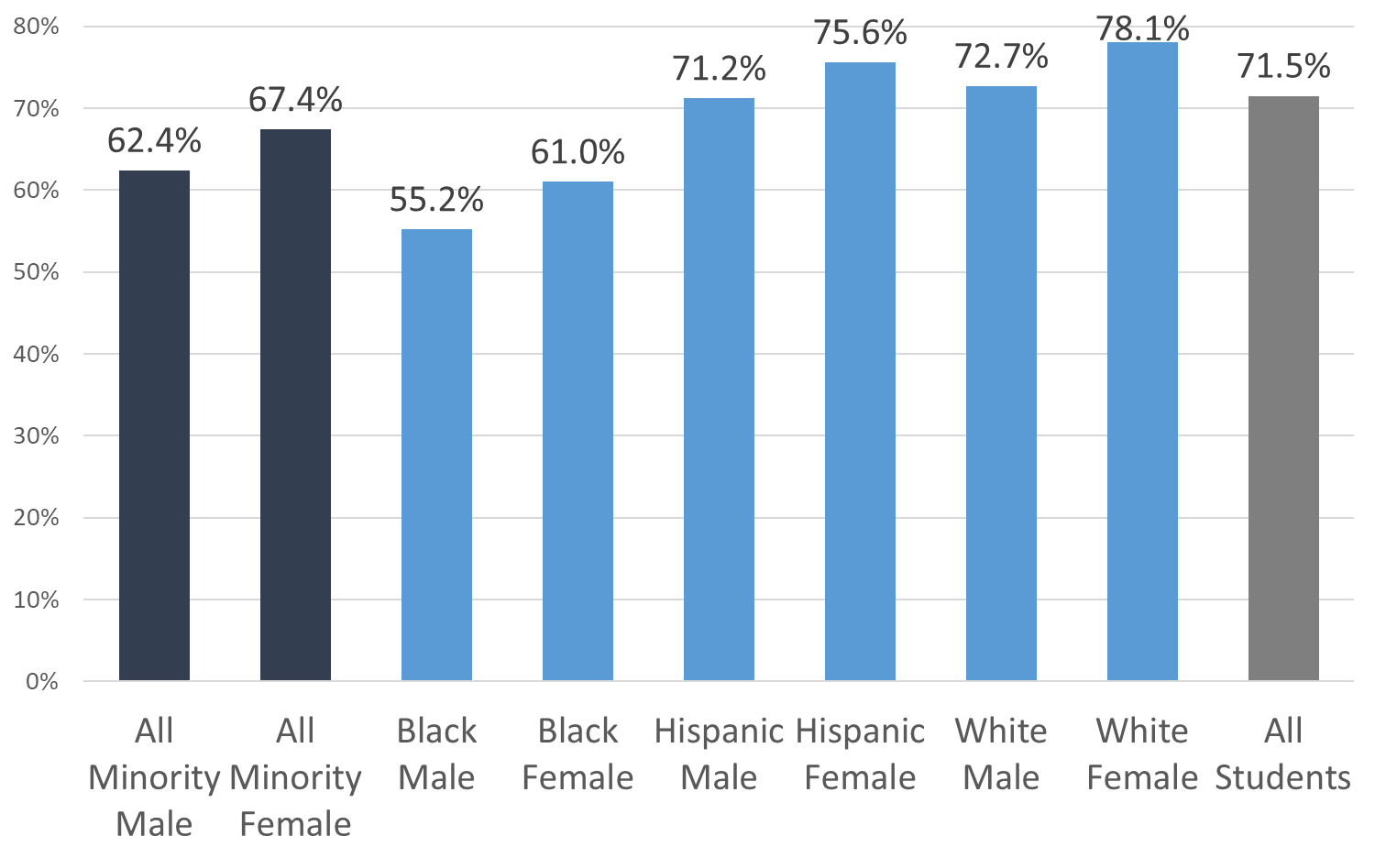

**First Year Progression** - Fall 2015 Cohort

Percentage of first‐time students attempting at least 12 hours within their first academic year who successfully complete at least 12 of those hours.

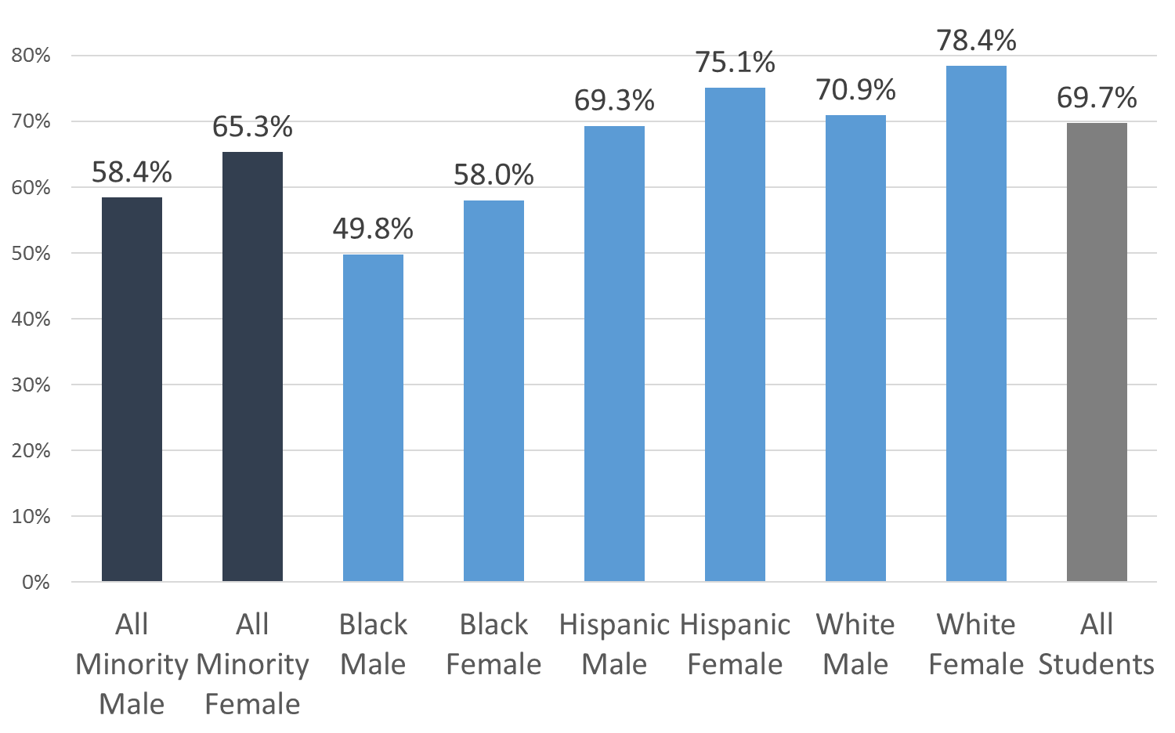

**Postsecondary Retention** - Fall 2015 Cohort

Percentage of first-time students enrolling in or graduating by the second fall semester

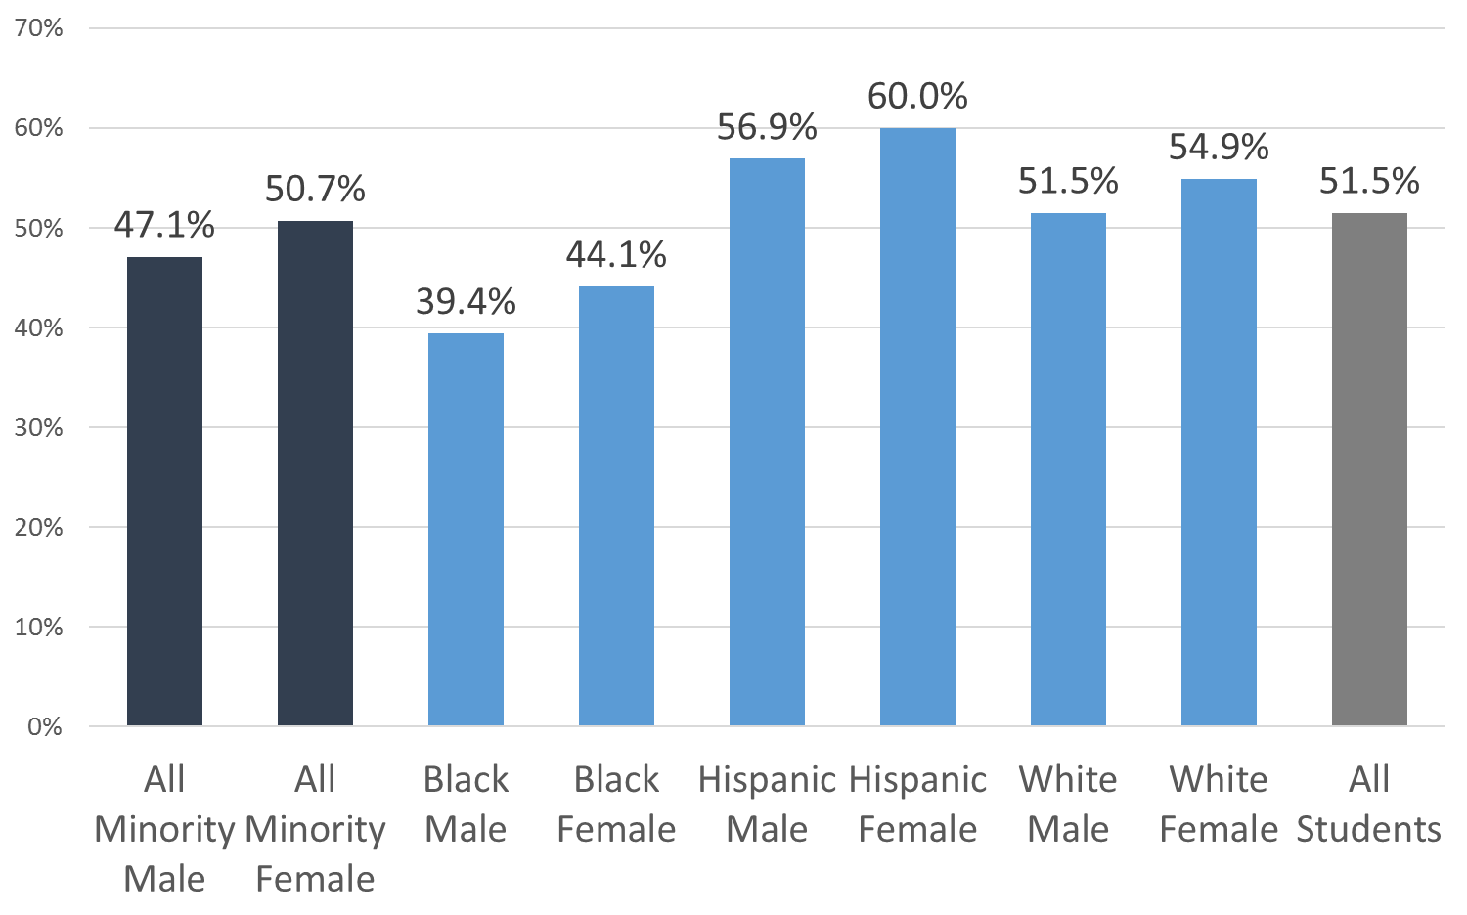

**Success Rate in College‐Level English Courses -** Fall 2014 Cohort

Percentage of first‐time Associate Degree seeking and transfer pathway students passing a credit‐bearing English course with a “C” or better within their first two academic years.

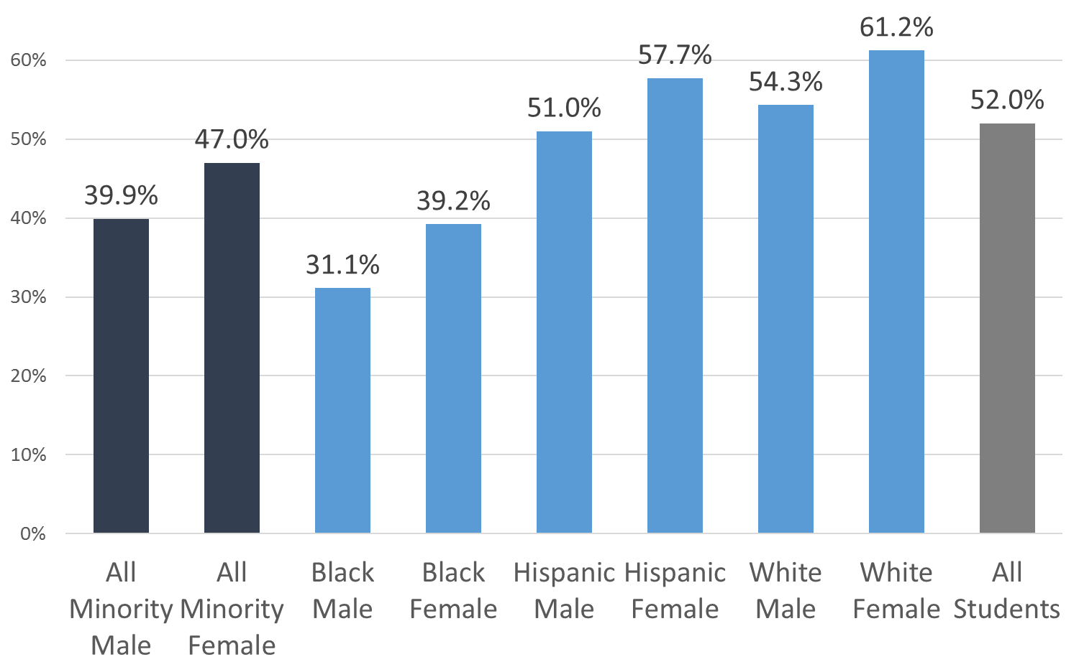

**Postsecondary Completion** - Fall 2015 Students

Percentage of all students graduating or transferring by the subsequent fall semester.

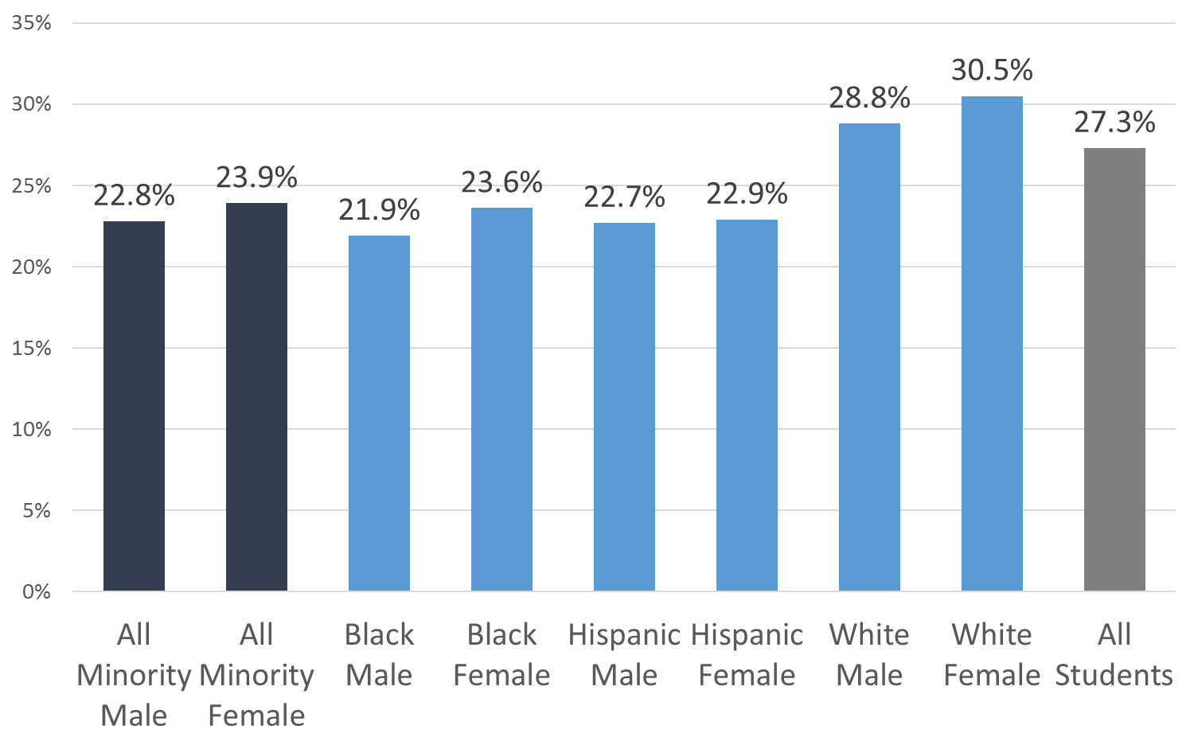

**Success Rate in College‐Level Math Courses** - Fall 2014 Cohort

Percentage of first‐time Associate Degree seeking and transfer pathway students passing a credit‐bearing Math course with a “C” or better within their first two academic years.

