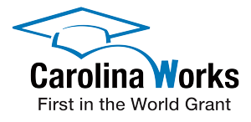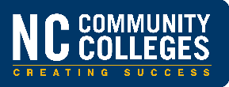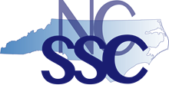

**Pathways to Transfer Success: Transfer Advising Workshop**

*Hosted by the NC Student Success Center and Carolina Works: First in the World (FITW) Grant Colleges*

**Thursday, March 1, 2018 10:00 a.m. to 3:00 p.m.**

**Mary Rittling Center | Davidson County Community College**

9:00 Networking and refreshments

10:00 **Welcome & Workshop Overview** Roxanne Newton

Executive Director, NC Student Success Center

**Greetings from Our College Host** Margaret Annunziata

Vice President, Academic Affairs | Davidson CCC

**NC Advising & Student Support Framework**

Daniel Alvarado, Associate Director, Student Services | NC Community College System

**Advising & Transfer Success: Lessons from the Transfer Advisory Committee & the Aspen Institute**

Wesley Beddard, Associate Vice President, Programs | NC Community College System

Stephanie Bailey, Director, Community College Partnerships | UNC System

10:45 **Transfer Success: Best Practices in North Carolina, Session I**

* **Proactive Advising Toward a New Advising Model**

Scott Byington, Dean of Arts, Sciences, and Advising | Central Carolina CC

* **Career Planning Choice and Opportunity: Inviting Students to Explore Careers and Majors** Charles Mayer, Director of Career Development | Davidson County CC
* **Academic Planning Mapping Pathways and Transfer Advising Collaborations**

Jenna Deal, Director, Student Advising & Testing Services | Asheville-Buncombe Tech CC

Steve Heulett, Coordinator, University Transfer | Asheville-Buncombe Technical CC

* **Financial Planning Empowering Students through Financial Literacy, Support & Policy Measures**

Lori Blevins, Director, Financial Aid | Davidson County CC

12:15 **Lunch & discussion**

12:45 **Transfer Success: Best Practices in North Carolina, Session II**

* **Timely Communication Proactive Success Coaching: High-Impact Strategies**  Sarah Deal, Project Director, Carolina Works: First in the World (FITW)

First in the World Success Coaches

* **Integrated Support & Intervention** **Connecting Students with Academic & Non-Academic Supports**  Sarah Deal & FITW Success Coaches & Workshop Attendees

1:30 **Pathways to Transfer Advising in Context: Case Studies**

2:45 **Evaluation & next steps**

3:00 **Adjourn**