# Virtual Program Visits

Here is a list of 16 questions that you will need to answer for 3 of the colleges located on virtual college slide. [North carolina institutions](https://www.northcarolina.edu/institutions/) <https://www.northcarolina.edu/institutions/>

Add 4 of your own questions to round the number to an even 20. What questions will you ask?

Once you get into the college page, you may need to search within the website for the location of the Family and Consumer Science or Education page to gather helpful information that may help you to make a wise decision.

1. Name of the College College Location:
2. Deadlines for Admission:
3. How and when do I apply for the college? Can I apply directly to the Education Program?
4. How do I apply for the Teacher Education/Family and consumer science Program?
5. What are the specific requirements for that program?
6. What is the program name and what majors or minors can you apply for?
7. Who is the Department Chair?
8. What percentage of students in the program are transfer students?
9. What is the cost of the college? What financial assistance is available for students?
10. Are there lab classes required in this program? What are the requirements of those classes?
11. Is Student teaching required in this program and how is placement in the program decided?
12. Does the Program have a Lab School? Are students able to do their observations at the lab school?
13. What is the ratio of faculty advisors to students in the program?
14. Are there any organizations for students in this field of study?
15. What is the programs commitment to improvement and excellence? What accreditation does it have?
16. What is the approximate time frame identified for completing this degree?

17 What type of mentoring and coaching is available in the program?

18

19

20

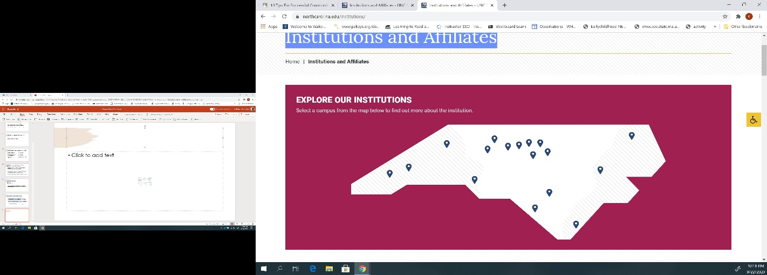

As you explore the institutions in the link above, you will soon notice that we are more than just blips on the map. We have a lot to offer. Which one will you choose? What was the deciding factor?